附件一：中文版简历模板
个人简历
姓 名 | 叶春林 | 性 别 | 男 | 出生日期 | 1969.4 | 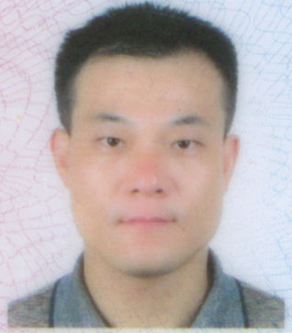
最后学历/学位 | 研究生/博士 | 职称 | 副教授 | 专 业 | 制药工程
邮箱 | chlye2005@126.com |  |  | 电话/传真 | 13858196979
地址 | C2-151 |  |  | 网址
教育背景 | 2002/3 - 2005/3，华东理工大学，生物化工，博士  1999/9 - 2002/3，浙江大学，化学工程，硕士  1986/9 - 1990/7，华东化工学院，无机化工，学士
研究领域 | 1. 抗肿瘤活性成分的发现  2. 肿瘤的靶向治疗  3. 肿瘤细胞信号转导通路
学术成果（出版著作、获奖及专利等） | 1. Chun-Lin Ye, Cheng-Jun Jiang. Optimization of extraction process of crude polysaccharides from Plantago asiatica L. by response surface methodology. Carbohydrate Polymers 2011; 84: 495-502.  2．Chun-Lin Ye, Wei-Lian Hu, De-Hui Dai. Extraction of polysaccharides and the antioxidant activity from the seeds of Plantago asiatica L. International Journal of Biological Macromolecules 2011; 49: 466-470.  3. Chun-Lin Ye, Yi-Feng Lai. Supercritical CO₂ extraction optimization of onion oil using response surface methodology. Chemical engineering & Technology 2012; 35: 646-652.  4. Chun-Lin Ye, Qi Huang. Extraction of polysaccharides from herbal Scutellaria barbata D. Don (Ban-Zhi-Lian) and their antioxidant activity. Carbohydrate Polymers 2012; 89: 1131-1137.  5. Chun-Lin Ye, De-Hui Dai, Wei-Lian Hu. Antimicrobial and antioxidant activities of the essential oil from onion (Allium cepa L.). Food Control 2013; 30: 48-53.  6. Chun-Lin Ye, Xuan-Gan Liu, Qi Huang. Antioxidant activity and protection of human umbilical vein endothelial cells from hydrogen peroxide-induced injury by DMC, a chalcone from buds of Cleistocalyx operculatus. South African Journal of Botany 2013; 86: 36-40.  7. Chun-Lin Ye, Xuan-Gan Liu, Qi Huang, Xian-Liang Zhao. Induction of apoptosis in human hepatoma SMMC-7721 cells using 2',4'-dihydroxy-6'-methoxy-3',5'-dimethylchalcone, a chalcone from buds of Cleistocalyx operculatus. Food Science and Biotechnology 2013; 22: 1421-1427.  8. Chun-Lin Ye, Yi-Feng Lai. Optimization of extraction process and antioxidant activity of polysaccharides from leaves of Artemisia argyi Levl. et Vant. Journal of Food Processing and Preservation 2015; 39: 1309-1317.  9. Chun-Lin Ye, Xuan-Gan Liu. Extraction of flavonoids from Tetrastigma hemsleyanum Diels et Gilg and their antioxidant activity. Journal of Food Processing and Preservation 2015; 39: 2197-2205.  10. Chun-Lin Ye, Yi-Feng Lai. 2′,4′-Dihydroxy-6′-methoxy-3′,5′-dimethylchalcone, from buds of Cleistocalyx operculatus, induces apoptosis in human hepatoma SMMC-7721 cells through a reactive oxygen species-dependent mechanism. Cytotechnology 2016; In press.
相关经历（学术交流、企业实践经历等） | 2014/05-2015/05，美国耶鲁大学，医学院，访问学者

