附件一：中文版简历模板
个人简历
姓 名 | 邢闯 | 性 别 | 男 | 出生日期 | 1986-09 | 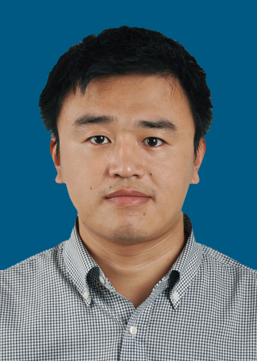
最后学历/学位 | 博士 | 职称 | 讲师 | 专 业 | 能源化工
邮箱 | chuangxing86@126.com |  |  | 电话/传真 | 15906670397
地址 | 杭州市留和路318号 |  |  | 网址
教育背景 | 2011/10–2014/9，日本 富山大学，环境应用化学科，博士，导师：椿范立  2009/10–2011/9，日本 富山大学，环境应用化学科，硕士，导师：椿范立  2005/9–2009/7，沈阳化工学院，应用化学学院，本科
研究领域 | 生物质基碳一化学品催化转化  催化剂设计及制备
学术成果（出版著作、获奖及专利等） | - C Xing, G Yang, P Lu, W Shen, X Gai, L Tan, J Mao, T Wang, R Yang, Noritatsu Tsubaki. A hierarchically spherical Co-based zeolite catalyst with aggregated nanorods structure for improved Fischer-Tropsch synthesis reaction activity and isoparaffin selectivity. Microporous and Mesoporous Materials, Doi: 10.1016/j.micromeso.2015.10.021, 2015, in press.  - C Xing, J Sun, G Yang, W Shen, L Tan, P Zhu, Q Wei, J Li, M Kyodo, R Yang, Y Yoneyama, N Tsubaki. Tunable isoparaffin and olefin synthesis in Fischer–Tropsch synthesis achieved by composite catalyst. Fuel Processing Technology, 2015, 136, 68-72.  - C Xing, J Sun, Q Chen, G Yang, N Muranaka, P Lu, W Shen, P Zhu, Q Wei, J Li, J Mao, R Yang, N Tsubaki. Tunable isoparaffin and olefin yields in Fischer-Tropsch synthesis achieved by a novel iron based micro-capsule catalyst. Catalysis Today, 2015, 251, 41-46.  - C Xing, G Yang, M Wu, R Yang, L Tan, P Zhu, Q Wei, J Li, J Mao, Y Yoneyama, N Tsubaki. Hierarchical zeolite Y supported cobalt bifunctional catalyst for facilely tuning the product distribution of Fischer-Tropsch synthesis. Fuel, 2015, 148, 48-57.  - C Xing, W Shen, G Yang, R Yang, J Sun, Y Yoneyama, N Tsubaki. Completed encapsulation of cobalt particles in mesoporous H-ZSM-5 zeolite catalyst for direct synthesis of middle isoparaffin from syngas. Catalysis Communications, 2014, 55: 53-56.  - C Xing, G Yang, D Wang, C Zeng, Y Jin, R Yang, Y Suehiro, N Tsubaki. Controllable encapsulation of cobalt clusters inside carbon nanotubes as effective catalysts for Fischer-Tropsch synthesis. Catalysis Today, 2013, 215: 24-28.
相关经历（学术交流、企业实践经历等） | - A hierarchically spherical Co-based zeolite catalyst with aggregated nanorods structure for improved Fischer-Tropsch synthesis reaction activity and isoparaffin selectivity. International Symposium on Zeolites and Microporous Crystals 2015. Hokkaido, Japan, 2015浙江科技学院第一单位，口头报告。  - An in–situ synthesis of low–cost mesostructured nickel nanoparticles embedded carbon/silica composite via a solid–liquid grinding route. The 13th China-Japan Symposium on Coal and C1 Chemistry 2015. Dunhuang, China. 浙江科技学院第一单位，口头报告.  - Novel iron based micro-capsule catalyst for the direct synthesis of middle isoparaffin from syngas. The 13th International Conference on Inorganic Membranes (ICIM), Brisbane, Australia, 2014.  - Catalytic cracking of 4-(1-naphthylmethyl)bibenzyl in sub- and supercritical water. 7th Tokyo Conference on Advanced Catalytic Science and Technology. Tocat 7, Kyoto, Japan, 2014.  - Facile synthesis of H-type zeolite shell on the silica substrate for tandem catalysis. The 17th Chinese Zeolite Conference. Yinchuan, China, 2013.  - Direct synthesis of middle isoparaffin from syngas using the completed encapsulation of cobalt particles in ordered mesoporous H-ZSM-5 as catalyst. The 7th International Symposium on Acid-Base Catalysis. Tokyo, Japan, 2013.  - Completed encapsulation of cobalt clusters in carbon nanotubes as catalysts for Fischer-Tropsch synthesis. Catalysis Today. Conference, Synfuel2012, Munich, Germany, 2012. 国际会议，口头报告。

