附件一：中文版简历模板
个人简历
姓 名 | 张妍 | 性 别 | 女 | 出生日期 | 1980-11-14 | 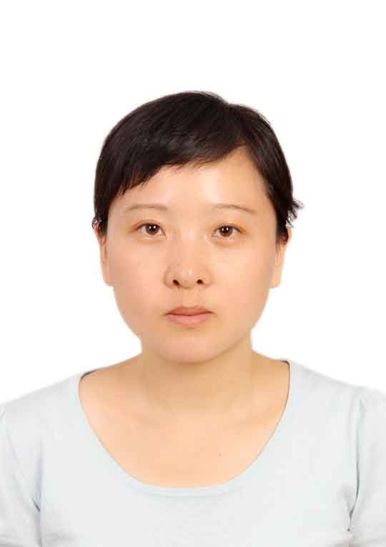
最后学历/学位 | 博士 | 职称 | 讲师 | 专 业 | 轻化工程
邮箱 | zyan1980@126.com |  |  | 电话/传真 | 057185070781
地址 | 浙江省杭州市西湖区留和路318号 |  |  | 网址
教育背景 | 2003 年6 月毕业于内蒙古师范大学，获理学学士学位。2003 年9 月进入中国科学院兰州化学物理研究所攻读硕士学位， 2006 年2 月提前攻读博士学位， 2009年6月获博士学位，师从夏春谷研究员所长。2012年11月进入日本横浜国立大学物质工学府访问1年3个月。
研究领域 | 多相催化剂的制备与应用，离子液体的合成及新型碳材料的制备
学术成果（出版著作、获奖及专利等） | 期刊论文：  - Yan Zhang, Yoshihiro Kubota, A Magnetically recyclable mesoporous Silica for Aldol Reaction, Catalysis Communications, 2015, 69, 92–96. (IF=3.32)  - Yan Zhang, Huifang Zhao, Zhijun Hu, Hua Chen, Xuejin Zhang, Qizhong Wo, Shiguo Zhang, Protic salts of high nitrogen content: a versatile precursor for graphitic carbon nitride and anionic effect on the structure, property and photocatalytic activity, Chem. Plus Chem., 2015, 80, 1139–1147 (IF=3.242)  - Yan Zhang, Xinjiang Cui, Feng Shi, Youquan Deng, Nano-gold catalysts in fine chemical synthesis, Chemical Reviews, 2012, 112, 2467-505. (IF=45.671 一区) cited by 176  - Yan Zhang, Xiujuan Qi, Xinjiang Cui, Feng Shi, Youquan Deng, Palladium catalyzed N-alkylation of amines with alcohols, Tetrahedron Letters, 2011, 52, 1334-1338. (IF=2.391 浙大top期刊) cited by 44  - Yan Zhang, Chungu Xia, Magnetic hydroxyapatite-encapsulated γ-Fe₂O₃ nanoparticle functionalized with basic ionic liquids for aqueous Knoevenagel condensation, Applied Catalysis A: General, 2009, 366, 141-147. (IF=3.674 浙大top期刊) cited by 62  - Yan Zhang, Yingwei Zhao, Chungu Xia, Basic ionic liquids supported on hydroxyapatite-encapsulated γ-Fe₂O₃ nanocrystallites: An efﬁcient magnetic and recyclable heterogeneous catalyst for aqueous Knoevenagel condensation, Journal of Molecular Catalysis A: Chemical, 2009, 306, 107-112. (IF=3.679) cited by 65  - Yan Zhang, Zhen Li, Wei Sun, Chungu Xia, Co-doped Attapulgite Catalyze Oxidation of Cyclohexane Using Molecular Oxygen, Catalysis Letters, 2009, 129, 222-227. (IF=2.291) cited by 5  - Yan Zhang, Zhen Li, Wei Sun, Chungu Xia, A Magnetically recyclable heterogeneous catalyst: Cobalt nano-oxide supported on hydroxyapatite-encapsulated γ-Fe₂O₃ nanocrystallites for highly efficient Olefin Oxidation with H₂O₂, Catalysis Communications, 2008, 10, 237-242. (IF=3.32) cited by 34  - Yan Zhang, Zhen Li, Wei Sun, Chungu Xia, Preparation, characteriazation and catalytic oxidation performance of Co Supported Attapulgite Catalysts, Journal of Molecular Catalysis (China), 2008, 22, 302-307. (IF=1.638)
相关经历（学术交流、企业实践经历等） | 2012 年11 月至2014年2 月前往日本横浜国立大学访问交流学习。

