附件二：英文版简历模板
CURRICULUM VITAE
Name | JinRong Li | Gender | Female | Date of Birth | 1977.12 | 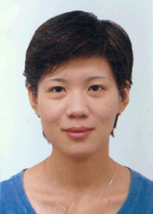
Diploma/Degree | Ph. D. | Professional Title | Associate professor | Major | Control science & engineering
Email | jrli@zust.edu.cn |  |  | Phone/Fax | 18868791680
Address | LiuHe Rd. 318# HangZhou |  |  | Website
Education | 2009/09-2013/06, Ph.D., Department of Control Science and Engineering, Zhejiang University  2000/09-2003.03, M.S., Department of Control Science and Engineering, Zhejiang University  1995/09-1999.06, B. S., Department of Computer Science and Technology, Zhejiang University
Research  Area | Wireless Sensor Networks, Intelligent Computation, Machine Learning
Academic Achievements (Publications, Honor and awards, Patent etc.)
Relevant Experience (Academic Exchange, visiting scholar, research etc.) | From Jan.,2015 to now, Zhejiang University of Technology Control Science & Engineering post-doctoral research center

