附件二：英文版简历模板
CURRICULUM VITAE
Name | WuYong | Gender | Male | Date of Birth | December,1969 | 照  片
Diploma/Degree | Bachelor | Professional Title | Senior Engineer | Major | 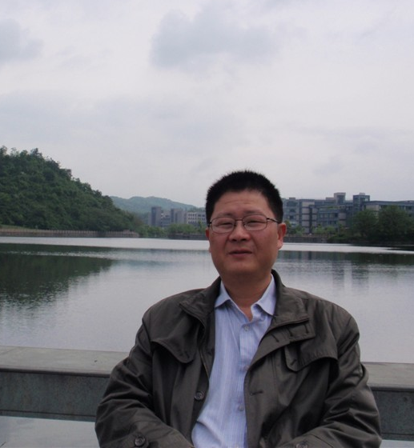  Electronic and Applied Technology | 照  片
Email | zdmqwy@163.com |  |  | Phone/Fax | 13905717425 | 照  片
Address | Gangwanjiayuan 15-2-402,Hangzhou,China |  |  | Website |  | 照  片
Education | Sep 1987-Jul 1991 Zhejiang University, Bachelor of Electronic
Research  Area | Safety Measurement For Motor Vehicle
Academic Achievements (Publications, Honor and awards, Patent etc.) | “ML-100 Automobile exhaust flow analyzer”win the Second Prize of New Industry Product in Zhejiang Province；
Relevant Experience (Academic Exchange, visiting scholar, research etc.) | Member of “SAC/TC 364 National Technical Committee for standardization of motor vehicle safety performance”and “SAC/TC 247 National automobile maintenance Standardization Technical Committee”

