附件二：英文版简历模板
CURRICULUM VITAE
Name | Shuguang Li | Gender | Male | Date of Birth | 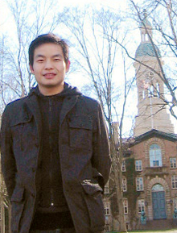  June, 1982 | 照  片
Diploma/Degree | Ph. D | Professional Title | Associate Professor | Major | Optics | 照  片
Email | lishuguang @ zust.edu.cn |  |  | Phone/Fax | +86 571 85070266 | 照  片
Address | No. 318, Liu-He Rd, Hangzhou 310023, China |  |  | Website | http://aee.zust.edu.cn | 照  片
Education | Sep 2006-Jun 2009 Zhejiang University Ph.D of Optics  Sep 2004-Jun 2006 Zhejiang University Master of Optics  Sep 2000-Jul 2004 Zhejiang University Bachlor of Physics
Research  Area | Photoelectric Detection, Precision Measurement
Academic Achievements (Publications, Honor and awards, Patent etc.) | 5 papers with high impact factors and total citation times up to 100.
Relevant Experience (Academic Exchange, visiting scholar, research etc.) | From year 2010 to 2012, As a Research Associate at Princeton University  In December 2015, A Cooperation Visit to Dresden University of Applied Science (HTW)

