附件二：英文版简历模板
CURRICULUM VITAE
Name | Kang Min | Gender | Male | Date of Birth | Nov.4,1980 | 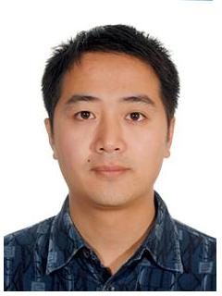
Diploma/Degree | PHD | Professional Title | Associate Professor | Major | Electrical Engineering
Email | kkkmin@yeah.net |  |  | Phone/Fax | 0086+13867419866
Address | Zhejiang University of Science and Technology,  318# Liuhe Road, Hangzhou 310023 |  |  | Website
Education | 2003.9- 2008.9 Zhejiang University Electrical Engineering PhD  1999.9-2003.6 Zhejiang University Electrical Engineering Bachelor
Research  Area | Electric machine and its drive system, multiphase motor, BLDC motor
Academic Achievements (Publications, Honor and awards, Patent etc.) | [1] KANG Min, HUANG Jin, YANG Jia-qiang，etal. Analysis and Calculation of Parameters of A Multiphase Induction Motor[J]. Proceedings of the CSEE，30(24):81-87，2010.  [2] Kang Min， Kong Wubin，Huang Jin. The Fault Tolerance Control of Five-Phase Induction Motor for Electric Vehicles[J]. Electric Machines and Control ,Vol.3,pp.1-6，2014
Relevant Experience (Academic Exchange, visiting scholar, research etc.) | 2012.10-2013.10 Hochschule Hannover，Germany, visiting scholar  2014.10- Fusheng Electrical Appliance Co.LTD, Hangzhou, Postdoctor

